Class: CSCI 6381 – Independent Research*
Final Project: The preparation of data, its labeling, and the comparison of different Machine and Deep Learning Classification methods using the data.
Name: Ulvi Bajarani
Student ID: 20539914
E-mail: ulvi.bajarani01@utrgv.edu
Phone: +19565305386
Supervisor: Dr. Zhixiang Chen
University: The University of Texas Rio Grande Valley (UTRGV)
Program: Masters of Science in Information Technology
Semester: Fall 2021
Repository: https://github.com/ulvi95/utrgv_final_project

*The class is the replacement for CSCI 6390 – Masters Project, which is deprecated according to the new degree plan for Fall 2021.
Introduction

Project focus

Machine Learning and Deep Learning are essential methods for various purposes, such as classification, anomaly detection, clustering, finding associations, and others. The focus of this project is on the comparison of various classification methods using the data prepared during the project. Additionally, the data is analyzed for statistical purposes.

Preliminaries

- Data – All data is prepared from the list of Azerbaijani electors in https://www.infocenter.gov.az/. The actuality of downloaded data is for the year 2020, because of the fact that the new security system doesn’t allow to download it without entering the provided captcha. All files are included in the \HTMLfilestoprocess folder. All people in the entries are at least 18 years old since the voting age in Azerbaijan is 18.

- Python packages:
  - BeautifulSoup4 – To process HTML files and prepare the required data. Is installed by pip install beautifulsoup4 command in the Command Prompt/Terminal.
  - Skicit-Learn – Multi-purpose package including various Machine Learning, Data processing, and Data analysis classes and methods. Is installed by pip install scikit-learn command in the Command Prompt/Terminal.
  - Scikit-learn-intelex – The Intel(R) Extension for Skicit-Learn to increase the speed. Used only for files in the \Py_SVMFiles_Accelerated folder. Has some restrictions, and consumes a lot of RAM. Is installed by pip install scikit-learn-intelex command in the Command Prompt/Terminal.
  - matplotlib.pyplot – The package to create various graphs. Is installed by pip install matplotlib command in the Command Prompt/Terminal.
  - NumPy – Multi-purpose package for efficient math operations and data structures. Is installed by pip install numpy command in the Command Prompt/Terminal.
  - Pandas – Multi-purpose package for efficient data processing and structures. Is installed by pip install pandas command in the Command Prompt/Terminal.
  - Keras (pip install keras) - The multi-purpose package for Neural Network analysis. Requires CUDA, GPU for efficient work. Is installed by pip install keras command in the Command Prompt/Terminal.
  - TensorFlow (pip install tensorflow) - The multi-purpose package for Neural Network analysis. Requires CUDA, GPU for efficient work. Is installed by pip install tensorflow command in the Command Prompt/Terminal.

Project activities

Preparation of the general .csv file for future analysis and labeling

This is done by the execution of 1_PyCSVCreation\create_csv_file.py file. The .py file processes all .htm and .html files in the \HTMLfilestoprocess folder, getting all data in the second tables of the files, and processes the data structured in these columns:

Number of electors in the file | County Code | District code | Elector’s Surname Name Patronymic | Elector’s home address | Year of birth

In the project, it is required to separate surnames, names, and patronymics. A problem is that not all entries might have the same structure. For example, other possible structures (N as Name, S as Surname, and P as Patronymic name) are (but not limited to)

N N \ S \ P
N \ S \ P P
N \ S S \ P

Due to this, the script replaces “ ” with “#”, and provides two splits in the “#” indices, because a direct split leads to a letter-by-letter split. If the entry hasn’t contained the patronymic, the patronymic field is replaced by “XXX”. Additionally, the Azeri letters that have been encoded wrongly are converted according to the table below:

Letter | IPA Transcription | Encoded by BeautifulSoup
Ç ç | [tʃ] | Г‡
Ə ə | [æ] | ЖЏ
Ğ ğ | [ɣ] | Дћ
I ı | [ɯ] | I
İ i | [ɪ] | Д°
Ö ö | [œ] | Г–
Ş ş | [ʃ] | Ећ
Ü ü | [y] | Гњ

The whole processing of 5561 files, despite the multiprocessing, took 3-4 days in Acer Aspire E5-575G. As a result, there are 5387803 entries where the number of problematic entries containing the “#” sign is 12194, which is about 0.23% of all entries. While all HTML files have 2.48 GB size, the resulting CSV file file_with_names.csv saved in the CSV_Files folder has 342 MB size.

The analysis of file_with_names.csv

It is done by the execution of .py files in the \PyStatisticalCounters folder. According to the file, the number of unique entities is provided below:

Surnames | Names | Patronymics
57209 | 72554 | 75407

While the average age of a voter is about 44.75, the median age of the voter is equal to 43.

The distribution of Year of birth is provided below:
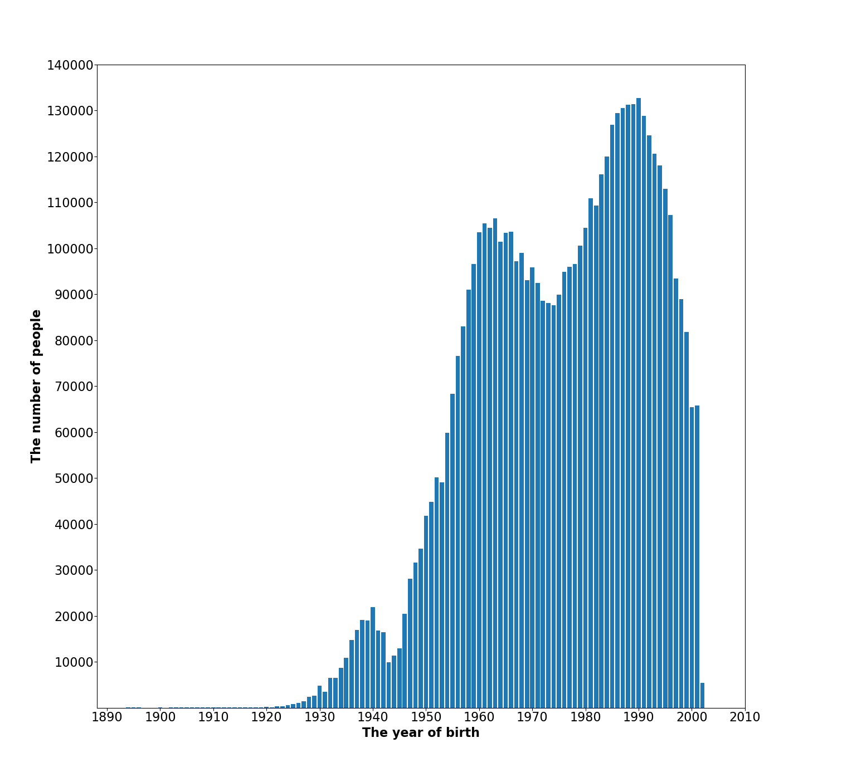
Two significant drops occurred in the 40s and between the 60s and 80s. The possible cause of the decrease in the 40s is World War II, and the cause of the drop between the 60s and 80s is the Dissolution of the Soviet Union followed by the First Nagorno-Karabakh War. Meanwhile, these observations are the topic of future researches.

Preparation of labeled .csv files for future analysis

This is done by the execution of .py files in \2_PyGenderDataCreation folder. The labeling is done by the rules for creation Azerbaijani surnames:

- For the file preparation_of_data_for_genders.py :

  - If a surname ends either with suffixes “-OV” or “-EV”, then it is labeled as “M” (Male);
  - Else if a surname ends either with suffixes “-OVA” or “-EVA”, then it is labeled as “F” (Female);
  - Else, it is labeled as “CBD” (Couldn’t be defined).

As all results in the remaining of the report, the results are saved in the \Results folder. The files with the data are surnames_labeled_all.csv containing all values and surnames_labeled_M_F_only.csv containing only values with “M” and “F” genders. The file surnames_labeled_M_F_only.csv contains 5047886 entries.

- For the file preparation_of_data_for_genders2.py , all conditions are the same except one more additional condition for 1)2)

  - If a name ends either with suffix “-Ə”, then it is also labeled as “F” (Female).

The files with the data are surnames_labeled_all_2.csv containing all values and surnames_labeled_M_F_only_2.csv containing only values with “M” and “F” genders. The file surnames_labeled_M_F_only_2.csv contains 5098896 entries.

The analysis of various Machine Learning and Deep Learning algorithms.

In this project, .py files for these Machine Learning and Deep Learning algorithms are created:

- Decision Tree (All .py files are stored in \Py_DecisionTreeFiles):
- With splitting criterion “entropy”;
- With splitting criterion “gini”;
- Naive Bayes (All .py files are stored in \Py_NaiveBayesFiles):
  - With Gaussian Naive Bayes algorithm;
  - With Multinomial Naive Bayes algorithm;
  - With Complement Naive Bayes algorithm;
  - With Bernoulli Naive Bayes algorithm;
- Support Vector Machine (All .py files are stored in \Py_SVMFiles):
- With Linear Kernel. To reduce the execution time, LinearSVC method is executed;
- With Polynomial Kernel, where degree=2;
- With Polynomial Kernel, where degree=3;
- With Polynomial Kernel, where degree=4;
- With Sigmoid Kernel;
- With RBF Kernel;
- Logistic Regression;
- K-Nearest Neighbors with K in the range [2; 10]; Additionally, the Euclidean and Canberra distance measures are compared to each other.
- Random Forest with the number of trees in {10, 25, 50, 75, 100, 150, 200, 300, 500}:
  - With splitting criterion “entropy”;
  - With splitting criterion “gini”;
- Multi-Layer Perceptron/Neural Network:
  - With one layer having 96 neurons;
  - With two layers having 48 neurons each;
  - With three layers having 32 neurons each;

In addition to 3, there are two additional folders with the same file names, but slightly changed code:

- The /Py_SVMFiles_Accelerated contains the files with Intel(R) Extension for Skicit-Learn.
- The /Py_SVMFiles_Accelerated contains the SVM classifiers with Cache Size equal to 1000 MB, while the default files uses 200 MB cache size only.
All files are executed with integer training data percentages in the range [1; 99]. All results are saved in separate .csv files. In addition to this, the whole percentage progress are might be easily followed in the output, since it is printed.

Each case has 24 Python files for each of the labeled files and these cases:

- The data with names containing no duplicates;
- The data with surnames containing no duplicates;
- The data with surnames and named containing no duplicates;
- The data with names containing duplicates;
- The data with surnames containing duplicates;
- The data with surnames and named containing duplicates;

The creation of graphs with results

The results of all cases might be output as various graphs. It is done with the files in the /PyGraphCreation folder. Each method has its file, executing the graphs with training data fraction in X-axis and the prediction accuracy in Y-axis. Additionally, there are other additional files:

- graph_creation_k_nearest_neigbors_Euclidean_canberra_comparison.py – The graph calculating the differences in the results of K-Nearest Neighbors Classifier with Euclidean and Canberra distances.
- graph_creation_k_nearest_neigbors_n_comparison.py – The comparison of maximums in various N values for K-Nearest Neighbors Classifier with Euclidean distance.
- graph_creation_k_nearest_neigbors_n_comparison_canberra.py – The comparison of maximums in various N values for K-Nearest Neighbors Classifier with Canberra distance.
- graph_creation_k_nearest_neigbors_n_comparison_Euclidean_canberra_difference_of_averages.py – The difference of averages between Euclidean and Canberra distances in various N values for K-Nearest Neighbors Classifier.
- graph_creation_random_forest_trees_comparision_entropy.py – The maximum results in the various number of trees for Random Forest Classifier with the criterion “entropy.”
- graph_creation_random_forest_trees_comparision_gini.py – The maximum results in the various number of trees for Random Forest Classifier with the criterion “gini.”

The legends for each graph are:

- Red plots, or scatters, or plots for “Names only” results.
- Green plots, or scatters, or plots for “Surnames only” results.
- Blue plots, or scatters, or plots for “Surnames and Names” results.

The work is done by classifiers

Since the execution of some files require a lot of resource and time, there are different results for the classifiers:

- All results of names and surnames without duplicates have been obtained all classifiers;
- In Naive Bayes and Logistic Regression, the results of all cases have been obtained;
- In Decision Tree Classifier, Support Vector Machine with Linear Kernel, K-Nearest Neighbors, all results of names, surnames, and surname+name with no duplicates are obtained.

- In the Decision Tree Classifier, the results of surname+name for the files surnames_labeled_all.csv and surnames_labeled_M_F_only.csv are obtained.

- For Random Forest Classifiers, the results for 10 and 25 trees are obtained.
The observation results

- If the probability of a feature is very low, “entropy” and “gini” splitting criteria in the Decision Tree Classifier provide identical results. In this case, “gini” is faster. With huge data, the result is different, since “entropy” is much faster;
- In Decision Tree Classifiers, increasing whole data size provides a significant increase in prediction accuracy;
- The Naive Bayes and Logistic Regression Classifiers are the fastest ones. Moreover, they show stable results with duplicates. The only exception is the Naive Bayes Gaussian;
- For K-Nearest Neighbors Classifiers, changing the distance metric from Euclidean to Canberra might give the accuracy increase up to 0.8%. This happens in big training data size and fractions;
- The number of N in K-Nearest Neighbors doesn’t have any significant effect on the accuracy;
- Increasing the number of layers together with keeping the number of neurons the same doesn’t change the maximum accuracy. But increasing the number of layers from 1 to N makes the classification model more stable;
- Decision Trees, Random Forests, and Support Vector Machines are the slowest ones, but Support Vector Machines (except LinearSVM) are slower than other ones;
- Sometimes, Random Forest Classifiers might provide 0% accuracy in some training data fractions;
- The number of degrees in Support Vector Machines with polynomial kernel doesn’t change the overall results significantly. In general, all SVM classifiers except the SVM with the sigmoid kernel provided the same pattern of results.
- Support Vector Machine with the sigmoid kernel is the slowest classifier among others.
- Generally, all classifiers scored better in binary classification problems than in multi-label classification problems.
- All classifiers require the data transformation from String, which makes them inefficient to predict the features of String data.
- Support Vector Machines, K-Nearest Neighbors, and Multi-Layer Perceptrons require either data standardization or normalization. In this project, the standardization is done by StandardScaler.
Future work that could be added

- It is possible to execute missing results from the section “The work is done by classifiers”;
- The possible comparison between the standardization methods for the Support Vector Machines, K-Nearest Neighbors, and Multi-Layer Perceptrons;
- The comparison between standardization and normalization in Support Vector Machines, K-Nearest Neighbors, and Multi-Layer Perceptrons;
- Checking the increase in the number of neurons for Multi-Layer Perceptrons;

Conclusion

Machine Learning and Deep Learning provided their efficiency in classification tasks. However, their overall efficiency and results in this project aren’t very high. The main reason is that features of the String data are lost by changing to a suitable type of data for a classifier, which makes the work of classifiers inefficient.

